1. Edit system environment variables

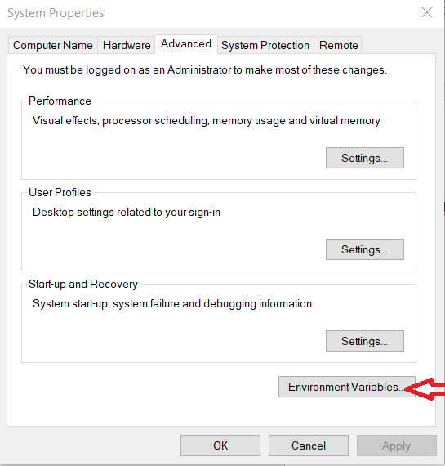

1. 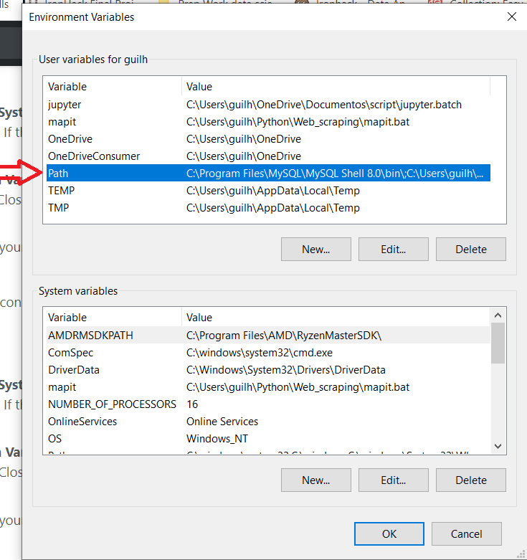~
2. A screenshot of a computer

   Description automatically generated

Windows key + R to access the run window and write the name of the batch file and the addresss